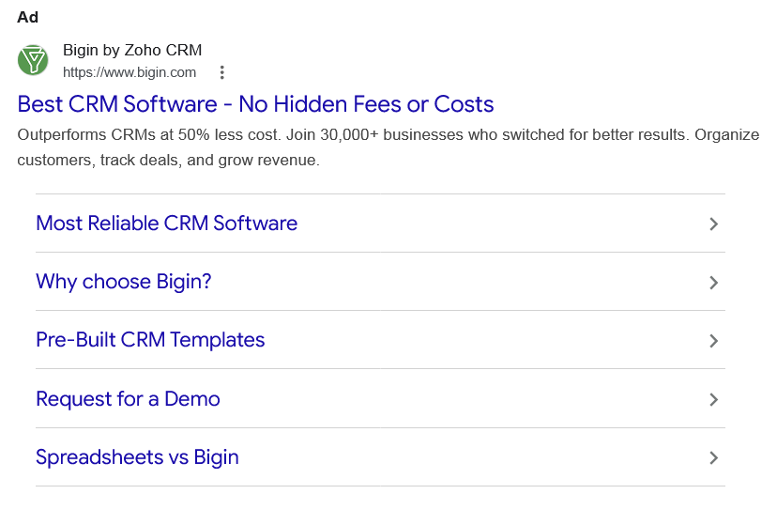
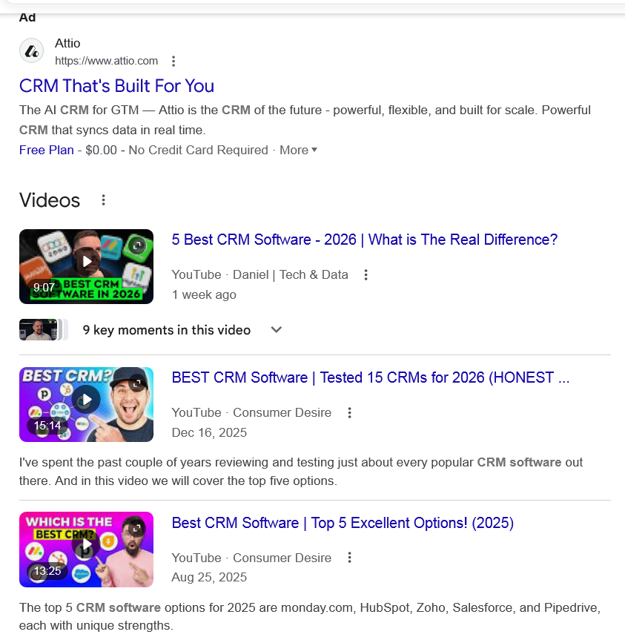
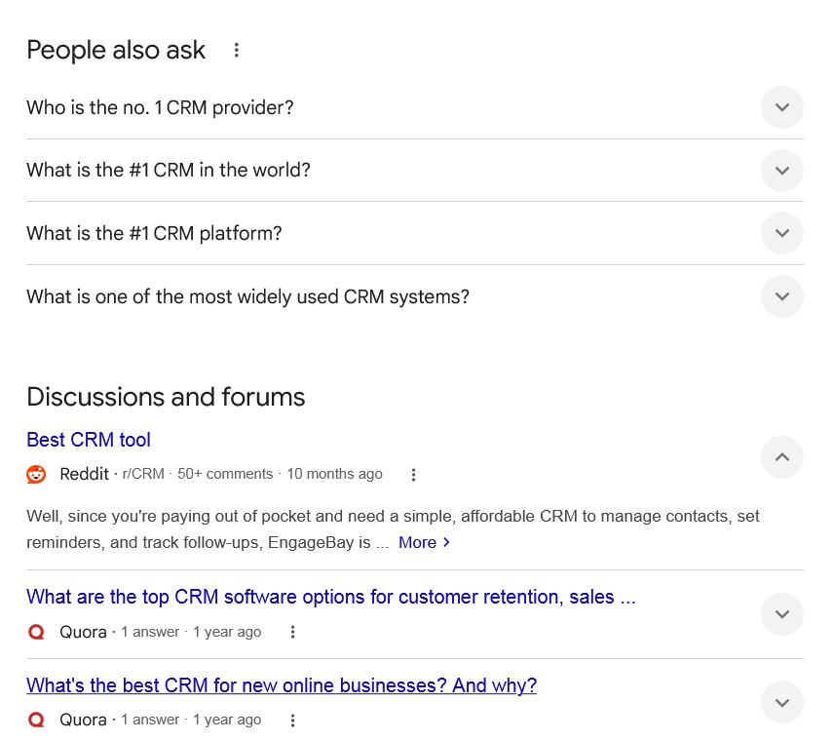
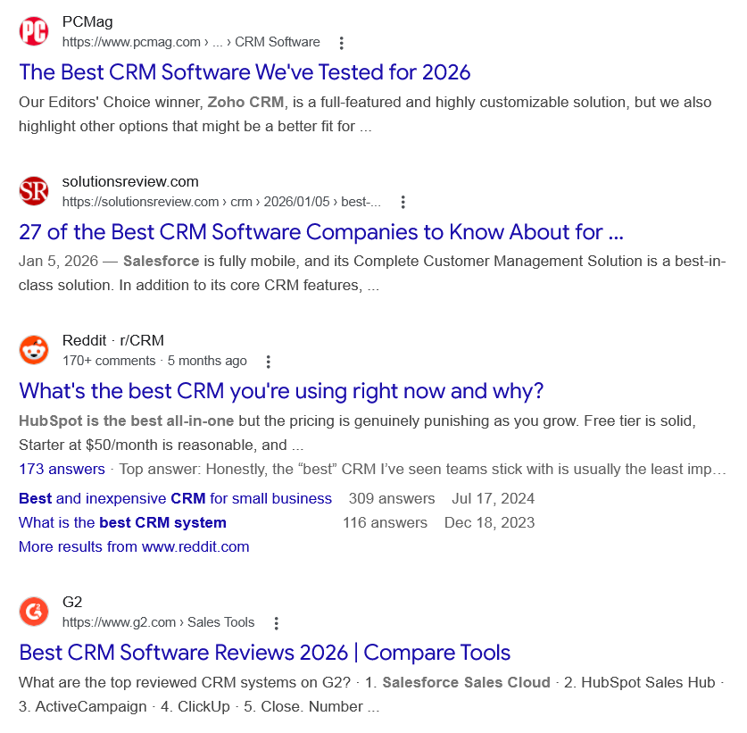
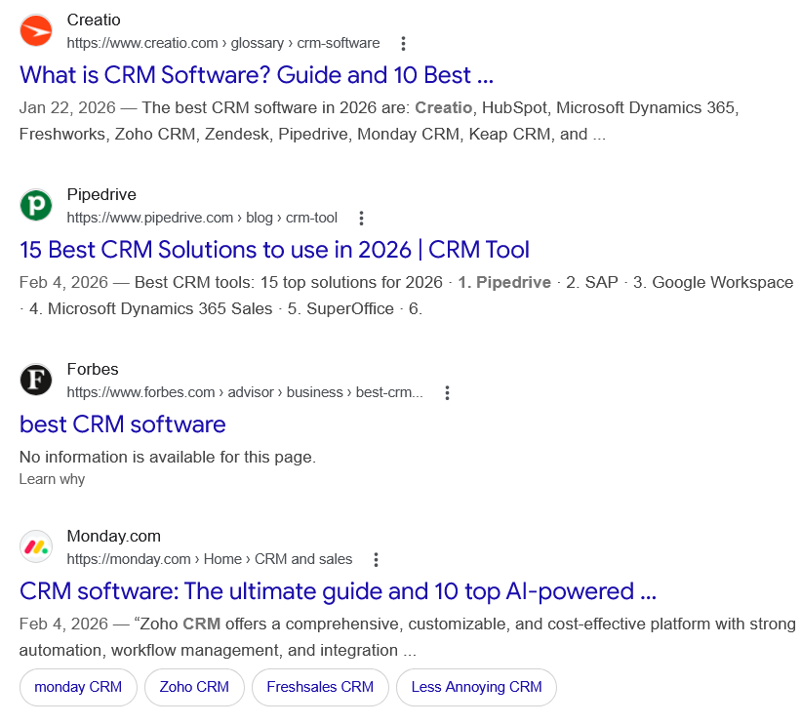
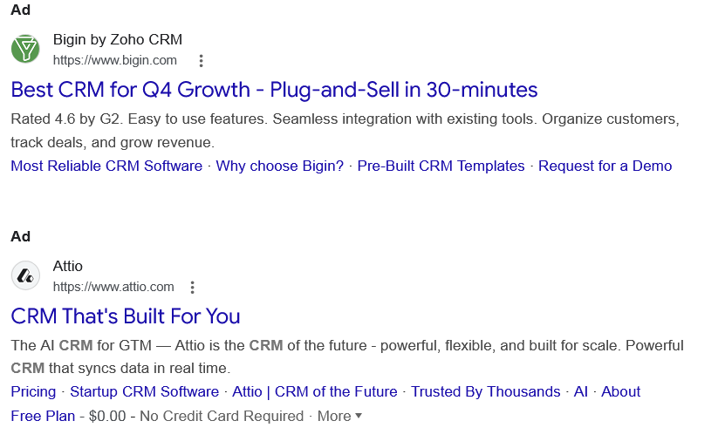
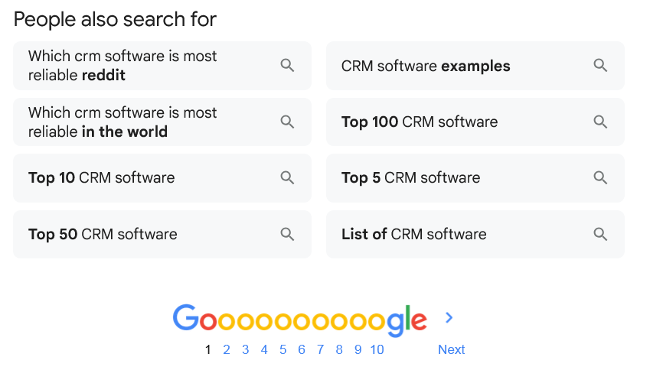
Ad

Best CRM Software - No Hidden Fees or Costs
Bigin by Zoho CRM
https://www.bigin.com

Bigin by Zoho CRM
https://www.bigin.com
My Ad Centre
Outperforms CRMs at 50% less cost. Join 30,000+ businesses who switched for better results. Organize customers, track deals, and grow revenue.

Most Reliable CRM Software

Why choose Bigin?

Pre-Built CRM Templates

Request for a Demo

Spreadsheets vs Bigin

People also search for
Ad

CRM That's Built For You
Attio
https://www.attio.com

Attio
https://www.attio.com
My Ad Centre
The AI CRM for GTM — Attio is the CRM of the future - powerful, flexible, and built for scale. Powerful CRM that syncs data in real time.
Free Plan - $0.00 - No Credit Card Required
· More

People also search for
Videos

5 Best CRM Software - 2026 | What is The Real Difference?
YouTube · Daniel | Tech & Data
1 week ago

YouTube · Daniel | Tech & Data
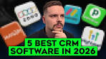9:07
9 key moments9 key moments in this video

From 00:00
5 Best CRM Software Review

From 01:00
What a CRM Should Actually Do

From 01:39
Option 1

From 02:59
Option 2

From 04:09
Option 3

From 05:10
Option 4

From 06:16
Option 5

From 07:08
Comparing the Real Differences

From 08:12
Final Thoughts

BEST CRM Software | Tested 15 CRMs for 2026 (HONEST ...
YouTube · Consumer Desire
Dec 16, 2025

YouTube · Consumer Desire
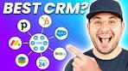15:14
I've spent the past couple of years reviewing and testing just about every popular CRM software out there. And in this video we will cover the top five options.

Best CRM Software | Top 5 Excellent Options! (2025)
YouTube · Consumer Desire
Aug 25, 2025

YouTube · Consumer Desire
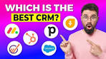13:25
The top 5 CRM software options for 2025 are monday.com, HubSpot, Zoho, Salesforce, and Pipedrive, each with unique strengths.

View all

People also ask
Who is the no. 1 CRM provider?

Salesforce is the #1 AI CRM, with AI agents, data, and CRM apps on a single, unified platform.
- Salesforce's category-leading apps for sales, service, marketing, commerce, IT, and more.
- It's always-on digital labour augmenting every employee, department, and business process to improve customer experiences.

World's #1 CRM | Salesforce IN

Salesforce
https://www.salesforce.com › worlds-number-one-crm

Salesforce
https://www.salesforce.com › worlds-number-one-crm
What is the #1 CRM in the world?

Salesforce
World's #1 CRM | Salesforce.

World's #1 CRM - Salesforce

Salesforce
https://www.salesforce.com › worlds-number-one-crm

Salesforce
https://www.salesforce.com › worlds-number-one-crm
What is the #1 CRM platform?
Salesforce is the #1 AI CRM and a trusted platform built to meet the needs of complex organizations. You can scale endlessly on a single, integrated platform.

The world's #1 AI CRM powers the Agentic Enterprise. - Salesforce

Salesforce
https://www.salesforce.com › crm

Salesforce
https://www.salesforce.com › crm
What is one of the most widely used CRM systems?
HubSpot is perhaps the most popular small business CRM since its core capabilities are free. Additional features, like enterprise licensing, can be purchased as an add-on to the commercially free options. HubSpot also has platforms and solutions for sales, service, content management, and operations.Jan 5, 2026

27 of the Best CRM Software Companies to Know About for ...

solutionsreview.com
https://solutionsreview.com › crm › 2026/01/05 › best-...

solutionsreview.com
https://solutionsreview.com › crm › 2026/01/05 › best-...
Discussions and forums

Best CRM tool
Reddit ·
r/CRM
· 50+ comments
· 10 months ago

Best CRM tool
Reddit ·
r/CRM
· 50+ comments
· 10 months ago
Well, since you're paying out of pocket and need a simple, affordable CRM to manage contacts, set reminders, and track follow-ups, EngageBay is ... More

What are the top CRM software options for customer retention, sales ...
Quora ·
1 answer
· 1 year ago

What are the top CRM software options for customer retention, sales ...
Quora ·
1 answer
· 1 year ago
top CRM software for customer retention, sales management, and lead generation are Salesforce, HubSpot, Zoho CRM, Pipedrive, ... More

What's the best CRM for new online businesses? And why?
Quora ·
1 answer
· 1 year ago

What's the best CRM for new online businesses? And why?
Quora ·
1 answer
· 1 year ago
The best CRM is the one your team loves using the most. Get your team together, map out your ... More
Top answer · 184 votes · 9 years ago
What do you need from your CRM & what problems you want it to solve? 1. What are your ... More
61 votes · 7 years ago
I've tried the following CRM's: 1. Elastic (Close.io [ http://close.io/ ]) 2. Nimble ... More
41 votes · 12 years ago

See more

Web results

The Best CRM Software We've Tested for 2026

PCMag
https://www.pcmag.com › ... › CRM Software

PCMag
https://www.pcmag.com › ... › CRM Software
Our Editors' Choice winner, Zoho CRM, is a full-featured and highly customizable solution, but we also highlight other options that might be a better fit for ...

27 of the Best CRM Software Companies to Know About for ...

solutionsreview.com
https://solutionsreview.com › crm › 2026/01/05 › best-...

solutionsreview.com
https://solutionsreview.com › crm › 2026/01/05 › best-...
Jan 5, 2026 — Salesforce is fully mobile, and its Complete Customer Management Solution is a best-in-class solution. In addition to its core CRM features, ...

What's the best CRM you're using right now and why?

Reddit · r/CRM
170+ comments · 5 months ago

Reddit · r/CRM
170+ comments · 5 months ago
HubSpot is the best all-in-one but the pricing is genuinely punishing as you grow. Free tier is solid, Starter at $50/month is reasonable, and ...
173 answers · Top answer: Honestly, the “best” CRM I’ve seen teams stick with is usually the least impressive on ...
Best and inexpensive CRM for small business
309 answers
Jul 17, 2024
What is the best CRM system
116 answers
Dec 18, 2023
More results from www.reddit.com

Best CRM Software Reviews 2026 | Compare Tools

G2
https://www.g2.com › Sales Tools

G2
https://www.g2.com › Sales Tools
What are the top reviewed CRM systems on G2? · 1. Salesforce Sales Cloud · 2. HubSpot Sales Hub · 3. ActiveCampaign · 4. ClickUp · 5. Close. Number ...

What is CRM Software? Guide and 10 Best ...

Creatio
https://www.creatio.com › glossary › crm-software

Creatio
https://www.creatio.com › glossary › crm-software
Jan 22, 2026 — The best CRM software in 2026 are: Creatio, HubSpot, Microsoft Dynamics 365, Freshworks, Zoho CRM, Zendesk, Pipedrive, Monday CRM, Keap CRM, and ...

15 Best CRM Solutions to use in 2026 | CRM Tool

Pipedrive
https://www.pipedrive.com › blog › crm-tool

Pipedrive
https://www.pipedrive.com › blog › crm-tool
Feb 4, 2026 — Best CRM tools: 15 top solutions for 2026 · 1. Pipedrive · 2. SAP · 3. Google Workspace · 4. Microsoft Dynamics 365 Sales · 5. SuperOffice · 6.

best CRM software

Forbes
https://www.forbes.com › advisor › business › best-crm...

Forbes
https://www.forbes.com › advisor › business › best-crm...
No information is available for this page.
Learn why

CRM software: The ultimate guide and 10 top AI-powered ...

Monday.com
https://monday.com › Home › CRM and sales

Monday.com
https://monday.com › Home › CRM and sales
Feb 4, 2026 — “Zoho CRM offers a comprehensive, customizable, and cost-effective platform with strong automation, workflow management, and integration ...
•
monday CRM

•
Zoho CRM

•
Freshsales CRM

•
Less Annoying CRM

Ad

Best CRM for Q4 Growth - Plug-and-Sell in 30-minutes
Bigin by Zoho CRM
https://www.bigin.com

Bigin by Zoho CRM
https://www.bigin.com
My Ad Centre
Rated 4.6 by G2. Easy to use features. Seamless integration with existing tools. Organize customers, track deals, and grow revenue.
‎Most Reliable CRM Software · ‎Why choose Bigin? · ‎Pre-Built CRM Templates · ‎Request for a Demo
Ad

CRM That's Built For You
Attio
https://www.attio.com

Attio
https://www.attio.com
My Ad Centre
The AI CRM for GTM — Attio is the CRM of the future - powerful, flexible, and built for scale. Powerful CRM that syncs data in real time.
‎Pricing · ‎Startup CRM Software · ‎Attio | CRM of the Future · ‎Trusted By Thousands · ‎AI · ‎About
Free Plan - $0.00 - No Credit Card Required
· More

People also search for

Which crm software is most reliable reddit

Which crm software is most reliable in the world

Top 10 CRM software

Top 50 CRM software

CRM software examples

Top 100 CRM software

Top 5 CRM software

List of CRM software

Page navigation
 | 1 | 2 | 3 | 4 | 5 | 6 | 7 | 8 | 9 | 10 | Next

